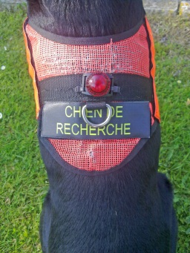 Chien sans frontiers with added weight loss in France 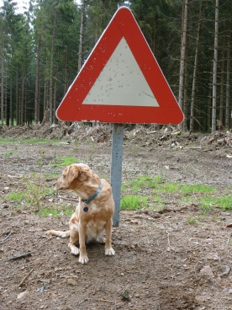
May 2012 and it’s our third annual trip to Dog Adventure for a SAR dog workshop. This year the course included two Dutch, one Belgian, and two from UK SAR teams and between us we brought seven dogs to participate.
It’s the first time Destiny had taken part in a Man Trailing course. We had done a little at home before arriving so we weren’t complete novices but we hadn’t tried trailing in a town before so it was surprising to find how challenging this is when compared to countryside. Destiny concentrated so hard so she even stepped over various lumps of bread that littered one trail in town! By the end of the course we were doing short multi junction urban trails and some quite long rural runs on one of which was a ‘scent team relay’ where three dogs each took stages of the trail to find the misper.
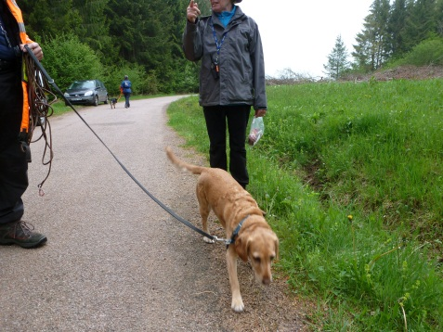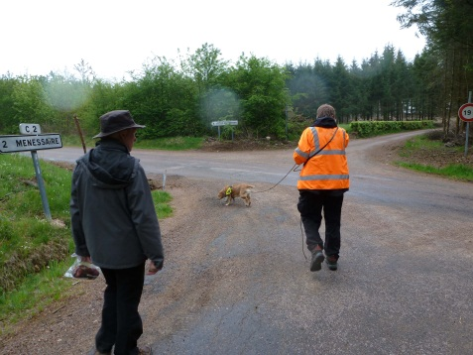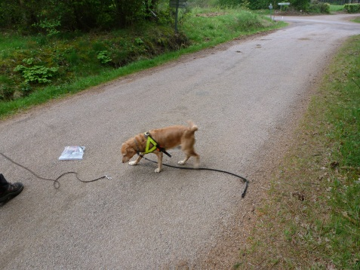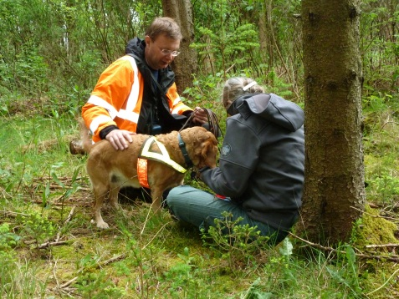
Destiny prepares, spots a weak link, seeks and then finds the ham at the end of a trail
Ella worked a variety of rural areas and edges of villages and except one afternoon when the local mice proved too strong a distraction for her, achieved some spectacular area search finds. There was some seriously hot days swiftly followed by an afternoon where the temperature fell to just above freezing and rain turned to hail and then snow whilst Ella gambled around as though it was just another day in scent paradise. On the last afternoon we worked a practical demonstration of just how a tight canopy of trees can produce a scent umbrella effect and that the scent will ‘leak out’ at the edges allowing dogs to scan and locate mispers at surprising distances from a path. Ella was so pleased she swung on the tuggy.
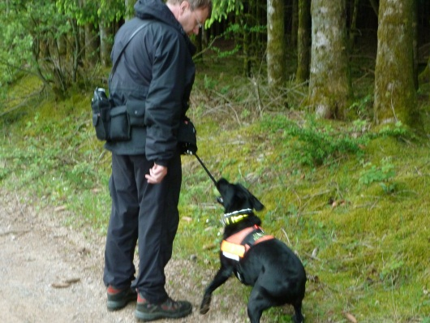
All other the dog teams on the course took great strides forward either as beginners or more seasoned man trailers. There are a few videos on the Dog Adventure web site that illustrate some dogs working and the standard achieved, the one of ‘Hiske and Richa’ is the start of an urban trail laid by me about 120 minutes before hand in a busy French Town on the Thursday morning. The number of cross trails must have been very large even in that time but Richa trailed to me through the town’s main shopping streets quickly and accurately. Richa’s been in training less than a year having swapped to trailing from air scent at Dog Adventure in June last year.
Food and accommodation was as before very good and here’s a bonus; I got home to find that despite the truly excellent home cooked food and the odd verre de vin I’d personally lost two kilos in 7 days! So go on holiday with your dog, meet great people and search for them, then eat and loose weight!
The Dog Adventure SAR weight loss plan has got to be the new F Plan!

